Displaying content

- A template : a web predisigned HTML page that’s used repetaedly by a sofware program (tempalte engine) to generate one or more HTML pages
- Web template engines : important part of any web application framework, most full-fledged frameworks have one
→ Many frameworks use a mix-and-match strategy that allows programmers to choose the template engine they prefer
- The Go standard library provides strong template support (text/template, html/template libraries)
→ Most Go frameworks support these libraries as the default template engine

I Templates/template engines

- Template engines often combine data/template to produce the final HTML
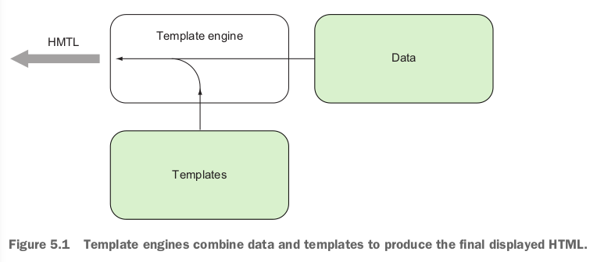
- Handlers usually call template engines to combine data with the templates and return the resultant HTML to the client

- Web template engines evolved from server-side includes (SSIs) which eventually branched out into web programming langages (PHP ColdFusion, JSP).
- As a result no standard exist for template engunes
- The feature of existing template engines vary depending on why they were created
- There are 2 types of template engines : Logic-less/Embedded logic template engines
- Logic-less : Dynamic data is substituted into the templates at the specified placeholders
→ The template engine doesn’t do any logic processing (only string subsitutions)
→ The idear is to have a clean separation between presentation/logic : the processing is only donne by the handlers
→ Faster to render because less processing is involved
→ The ideal logic-less template engine would be impractical and placing more logic into the handlers would add unecessary complexity to the handlers
- Embedded logic : programming langage code is embedded into the template/executed during runtime by the tempalte engine, including subsitutions : makes it very powerful
→ The code is harder to maintain because the logic is sembedded in the template itself : the presentation and logic are mixed up together and logic is distributed in multiple places
→ Indistinguishable from a computer program itself (we can see it with PHP)
→ PHP originated as a standalone web template engine but today many PHP pages are written without a single HTML line
- Most usefull template engines would lie between these 2 ideal types : Go template engine is such a hybrid
→ can be used as logic-less but there’s enough embedded features to make Go interesting and powerful

II Go template engine

- In a web app the handler usually triggers the template engine
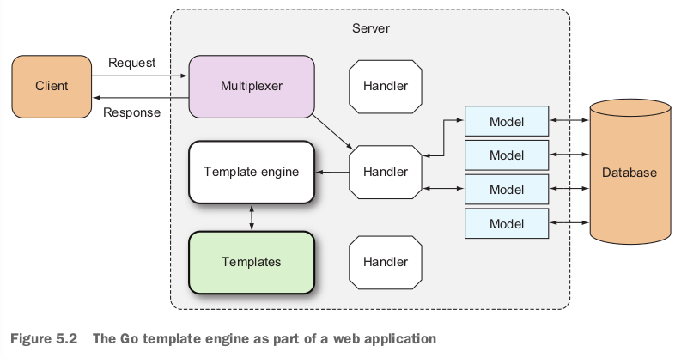

- The handler provides the template engine with the necessary templates (in a form of a list of template files) along with the dynamic data
- Then the template engine creates the HTML content and sends it to the ResponseWriter which includes the HTTP Response that is sent back to the client
- Go templates are txt docs (for web aps : HTML files) with certain commands embedded in them (actions)
→ The txt is parsed and executed by the template engine to produce another piece of txt
→ text/template : any type/text format
→ html/template : specific to HTML
- Actions are added between 2 double braces {{ }}
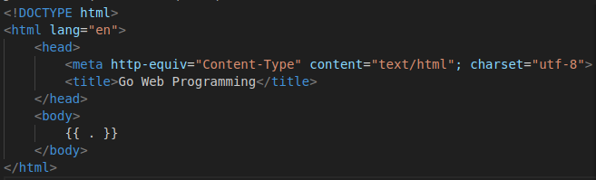

- We can have as many template files as we’dlike, they must be in a readable txt format but can have any extension
- {{ . }} : it’s an action, a command for the tempalte engine to replace it with a value when the template is executed
- Using the Go web template engine requires 2 steps :*
→ Parse the txt formatted template source to create a parsed template struct
→ Execute the parsed template passing a ResponseWriter and some data to it, this triggers the template engine to combine the parsed template with the data to generate the final HTML that’s passed to the ResponseWriter
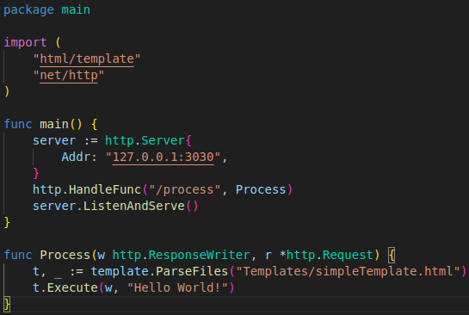

- We have a handler function named Process that triggers the template engine
→ First we parse the template file using the ParseFiles func which returns a parsed template « Template, error »
→ Then we call the Execute method to apply data (« Hello World ! ») to the template
- We pass in the ResponseWriter along with the data so that the generated HTML can be passed into it
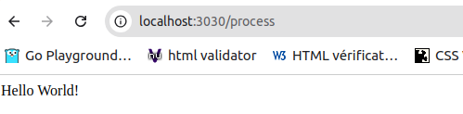

A) Parsing templates

- ParseFiles is a standalone func that parses template files and creates a parsed template struct that we can execute later
- The ParseFiles is a convenience func tot the ParseFiles method on the Template struct
- When we call the ParseFiles func Go creates a new template with the name of the file as the name of the template

- Then it calls the ParseFiles method on that template
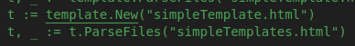

- ParseFiles (func/method) can take one or more filesnames as parameters (making it a variable func : func that can take in a variable number of parameters)
→ It still returns just one template regardless of the number of files it’s passed
→ When we pass in more than one file the returned parsed template has the same name /content of the first file
→ The rest of the files are parsed as a map of templates which can be reffered to later on during the execution
→ It’s as if the ParseFiles returns a template when we provide a single file and a template set when we provide more than one file
- Another way of parsing files is using the ParseGlob func which uses pattern matching instead of specific files

